

***School of Mechanical & Manufacturing Engineering (SMME),***

***National University of Science and Technology (NUST),***

***Sector H-12, Islamabad***

Program: BE-Aerospace Section: AE-01

Session: Spring 2024 Semester: 2nd

Course Title: Engineering Drawing (AE-103)

**Assignment #2**

***AutoCAD***

***Name: Muhammad Arriyaan Ali***

***CMS: 456787***

**Introduction & Abstract:**

The main goal of the engineering drawing assignment was to familiarize students with the principles and techniques of orthographic projection. Specifically, we focused on using the first-angle view method within the AutoCAD environment. By completing this assignment, I gained the ability to accurately depict three-dimensional objects in two dimensions, while also developing an understanding of projection systems and technical drawing conventions.

**Descriptions:**

* **Orthographic Projection:** A fundamental technique used in technical drawing to represent the three-dimensional form of an object in two dimensions by projecting its views onto perpendicular planes.
* **First Angle Projection:** A method of orthographic projection wherein the object is situated in the first quadrant of 3D space, and its views are projected onto planes positioned between the object and the observer.
* **Visible Edges:** The lines representing the outlines and features of the object that are directly visible in the orthographic projections.
* **Hidden Edges:** Lines representing features of the object that are obscured from direct view in the given projections but are essential for conveying complete information about the object's geometry.
* **Centre Lines:** Lines indicating the center of symmetry, rotation, or other significant features of cylindrical or symmetrical parts.

**Spacing Data:**

$Vertical Spacing$

$$=\frac{\left[Total Height of Sheet –\left(Height of Object+ Depth of object\right)\right]}{3}$$

$Horizontal Spacing$

$$=\frac{\left[Total Width of sheet–\left(Width of Object + Depth of object \right)\right]}{3}$$

|  |  |  |
| --- | --- | --- |
| Drawing No | Vertical Spacing | Horizontal Spacing |
| 1 | 14.33 | 15 |
| 2 | 5.133 | 4.8 |
| 3 | 2.733 | 3.2 |

**Procedure:**

To create the engineering drawing, following were the steps:

1. **Projection Formation:**
   * Generate the front, top, and side views of the object using the principles of first angle projection.
   * Position each view carefully relative to the others, adhering to the conventions of first angle projection.
2. **Line Differentiation:**
   * Assign appropriate colours and line types to differentiate between visible, hidden, and centre lines. This ensures clarity and readability of the drawing.
3. **Layout Finalization:**
   * Arrange the projection views systematically within the drawing space.
4. **Dimensioning:**
   * According to the size of the drawing the size of the dimensions were adjusted.
   * Dimension lines, extension lines and texts were differentiated from the rest of the drawing using different colours.

**Drawing 1:**

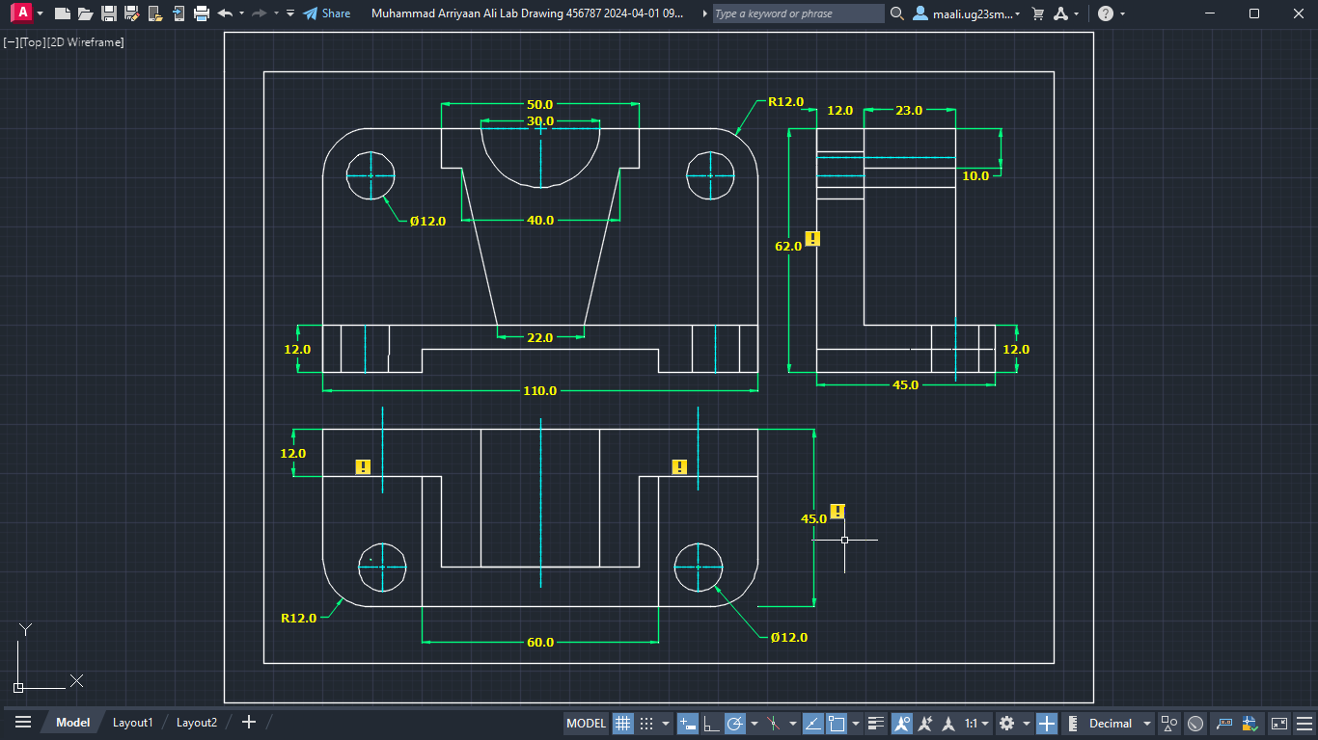

Figure 1: Orthographic First Angle Projection of Drawing 1

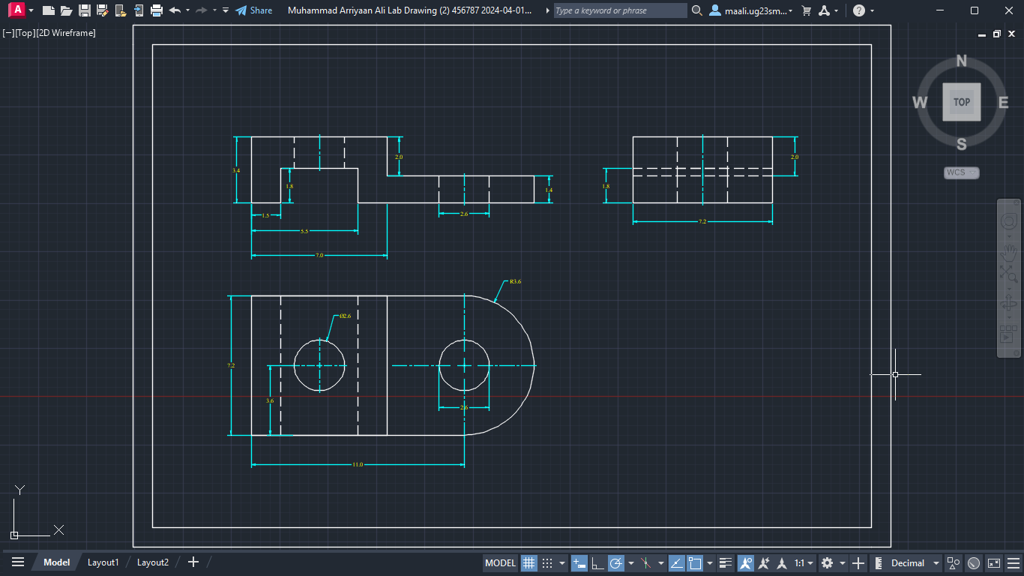**Drawing 2:**

Figure 2:Orthographic First Angle Projection of Drawing 2

**Drawing 3:**

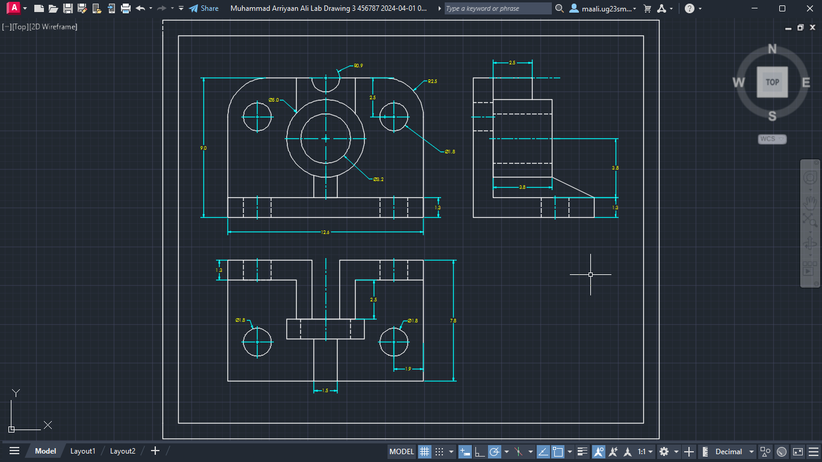

Figure 3:Orthographic First Angle Projection of Drawing 3